Install MySQL for Linux

Install MySQL for Debian-based systems (such as Ubuntu):
sudo apt-get update
sudo apt-get install mysql-server

Check if it is installed
mysql --version

Start the service
sudo systemctl start mysql

To run secure script (IMPORTANT):
sudo mysql_secure_installation

Choose a password and remember it

Remove anonymous users Y
Disallow root login remotely? Y
Remove test database ? N

To allow MySQL through firewall:
sudo ufw enable
sudo ufw allow mysql

To install workbench
sudo apt-get install mysql-workbench-community
OR
snap install mysql-workbench-community
sudo snap connect mysql-workbench-community:password-manager-service :password-manager-service
(a Snap package is sandboxed; it is not by default allowed to access this service. When you choose "Store in keychain" MySQLWorkbench is blocked by AppArmor. )

Create a user on MySQL
sudo mysql -u root -p

You will be prompted for a root password which you created earlier

> CREATE USER 'user'@'localhost' IDENTIFIED BY 'password';
Replace ‘user’ with the username of your choice. ‘localhost’ is the host where you will create the user. And in ‘password’ enter the password for this new user. Similarly, it is recommended that it be a strong password.

GRANT ALL PRIVILEGES ON *.* TO 'user'@'localhost' WITH GRANT OPTION;

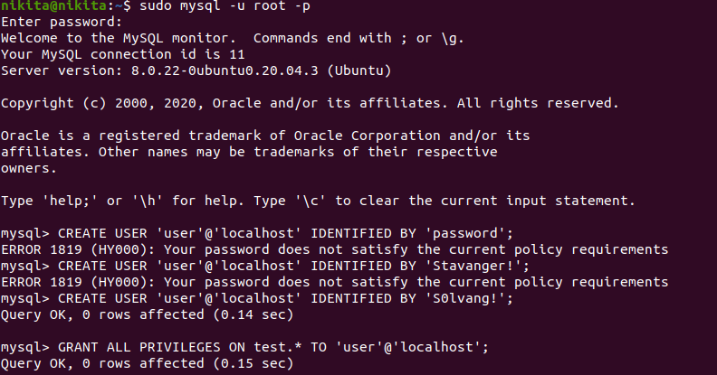

Launch the MySQL Workbench application by clicking on the icon generated.
On the home page, right click on Local Instance 3306 and click on edit connection

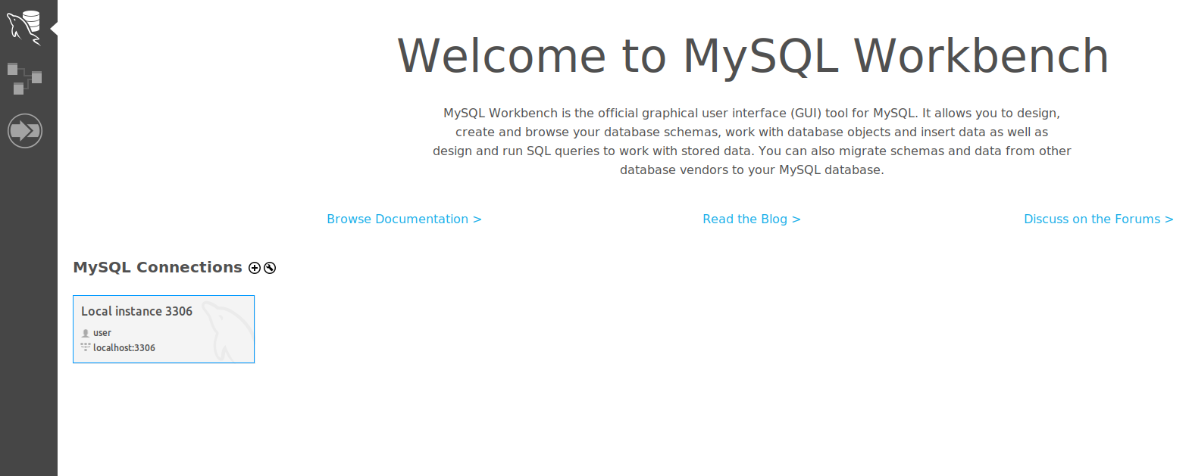

Change the Username and password to the username and password of the user you created before. Then click on Test connection.
If that works, close this window and from the home window right click and select open connection.

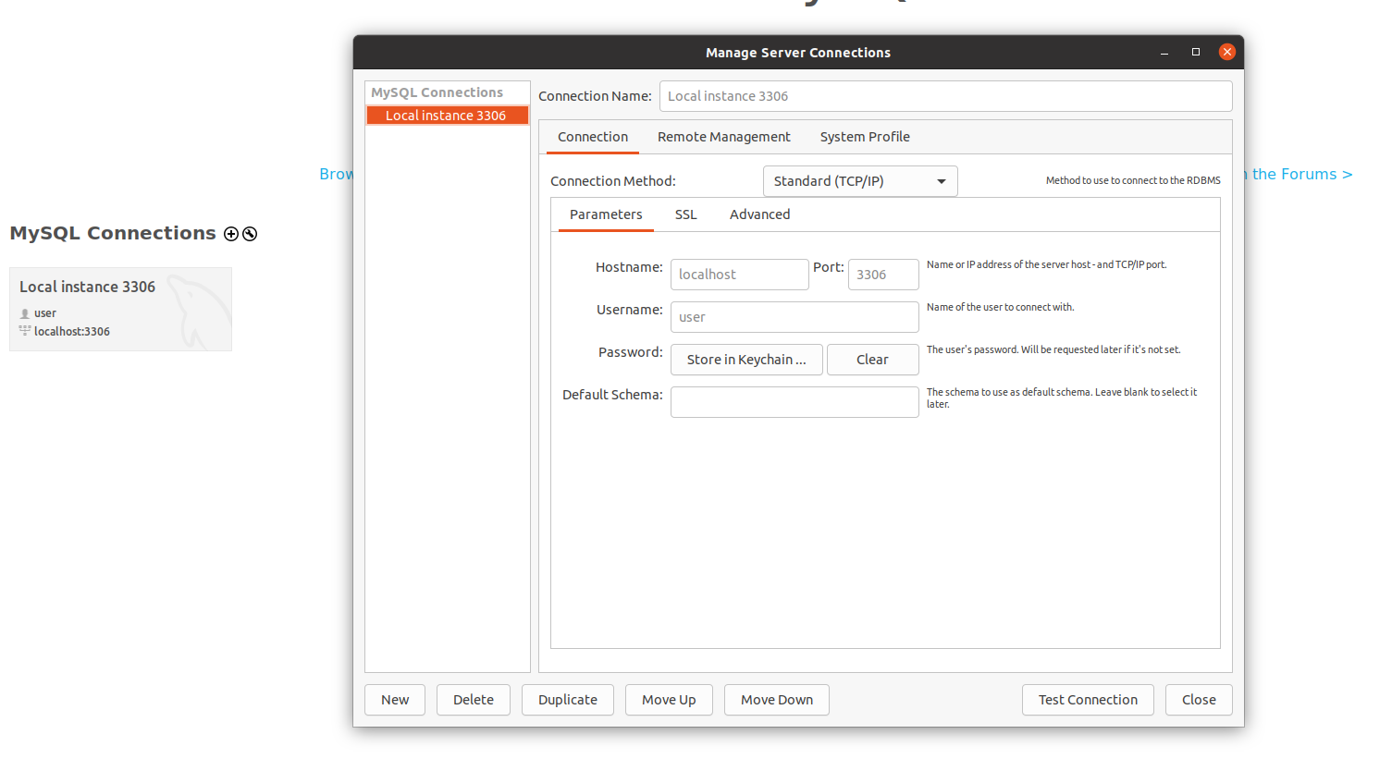

Testing installation

CREATE DATABASE mydb;
USE mydb;

CREATE TABLE Person (Id int(10) NOT NULL, name varchar(10), last_name varchar(10));

INSERT INTO Person (Id, name, last_name) VALUES (1,'Richard','Winters');

SELECT * FROM Person
DROP TABLE Person;

Uninstall- please follow these instructions should you need to uninstall. Deleting folders corresponding to mysql and other solutions are presented on various forums. However, in my experience once these commands are run, it becomes a hassle to reinstall mysql.
sudo apt-get remove mysql-server
sudo apt-get autoremove
sudo apt-get remove package-name

To see a list of packages you have installed from the MySQL APT repository, use the following command:
dpkg -l | grep mysql | grep ii

In case of more issues, as a last resort. Please back up any data:
sudo apt-get remove --purge mysql-\*

Troubleshooting

If using Ubuntu 20.4 and if you encounter the following issue:
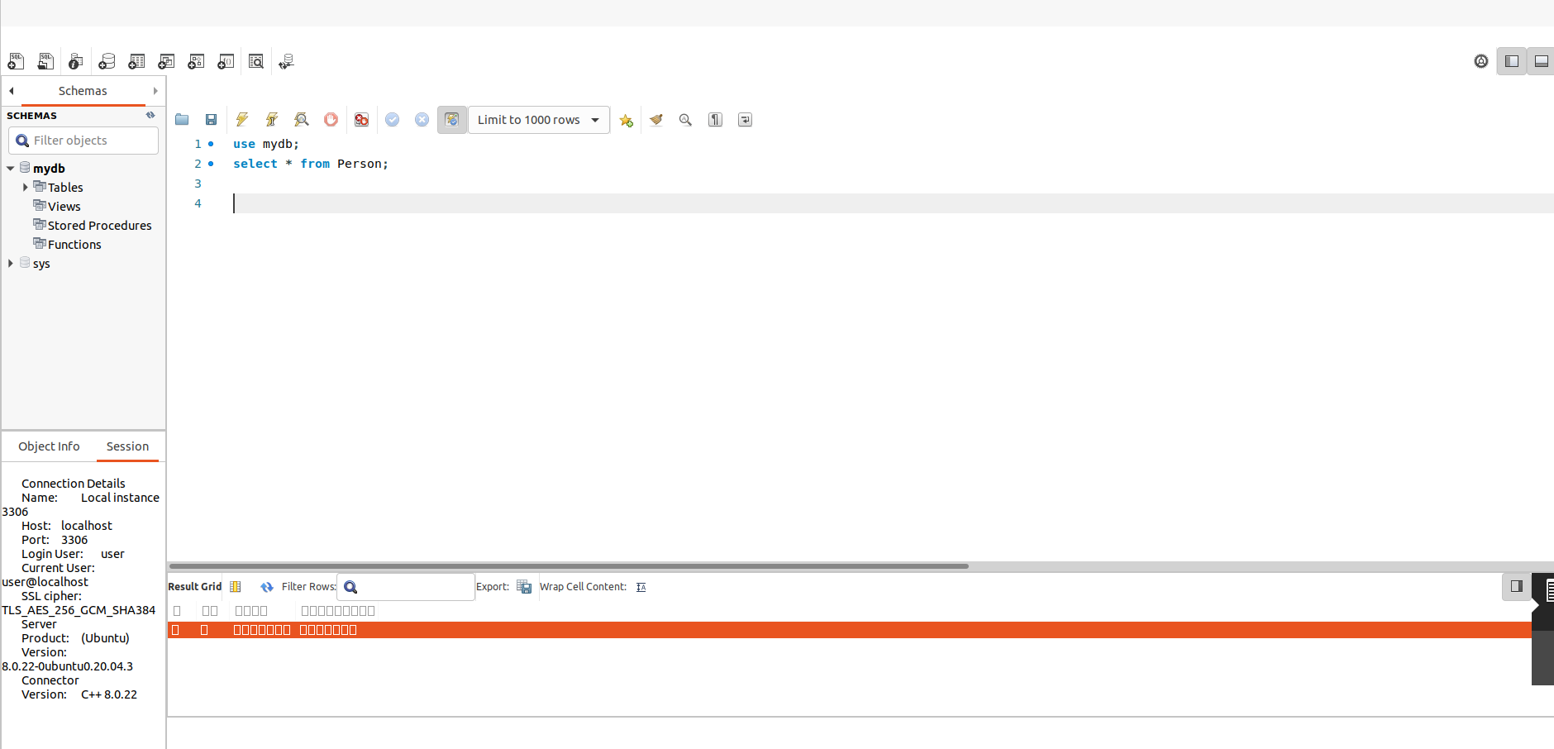

https://stackoverflow.com/questions/63696603/display-errors-in-mysql-workbench

